Software for the Application of Generalizability Theory

SAGT

User manual

English

User manual for the SAGT application: Software for the Application of Generalizability Theory. Version 2.0.
This manual forms part of several final-year projects for Computer Engineering degrees at the Higher Technical School of Computer Engineering of the University of Málaga (Spain).

Developed by the students (Project Authors):
Francisco Jesús Ramos Pérez
Fernando Jesús Ruano Linares
Supervised by:
Prof. Dr. Antonio Hernández Mendo
Prof. Dr. José Luis Pastrana Brincones
Methodological Adviser:
Prof. Dr. Ángel Blanco Villaseñor


Contents

1 Welcome 5
1.1 System requirements 5
1.2 Installing SAGT 5
2 Main menu 9
3 Connect/Disconnect 10
4 Projects 12
4.1 Create project 12
4.2 Edit project 12
4.3 Search project 12
4.4 Assign director 13
5 Generic actions 14
5.1 Save 14
5.2 Open 14
5.3 Information tabs 15
5.4 Import 16
5.5 Reports 16
5.6 Export Excel 16
5.7 Close 16
6 Data 17
6.1 Theoretical principles 17
6.1.1 Definition of the facets 17
6.1.2 Arrangement of the facets 18
6.1.3 Table of observations 19
6.2 Creating the table of observations 21
6.2.1 Import scores 24
6.3 Arrangement of facets in mixed designs 25
6.4 Edit facets 26
6.5 Edit table of observations 27
6.6 Omit facets 27
6.7 Skip levels 28
6.8 Hide null values 28
6.9 Import data 29
6.10 Build means 31
6.11 Analyze 32
6.11.1 Analyze with VCA 32
6.12 Export scores 33
6.13 Export CSV 33
7 Means 34
7.1 Types of tables of means 34
7.2 Import means 34
8 Analyses 36
8.1 Tabs 36
8.1.1 Sum of squares 36
8.1.2 G-Parameters 41
8.1.3 Optimization 43
8.2 New sum of squares 43
8.3 Edit 45
8.4 Change model 46
8.5 Import analysis 46
8.6 Optimization levels 47
8.7 Charts 48
8.8 Export squares 50
9 Tools 51
9.1 Settings 51
9.1.1 Reports tab 51
9.1.2 Charts tab 52
9.1.3 Connection tab 53
10 Help 55
11 Credits 56

SAGT user manual

1 Welcome
SAGT is a tool for the application of Generalizability theory. SAGT is an acronym for Software Application for Generalizability Theory. It can carry out estimation and optimization tasks on the facets of a Generalizability study automatically, including graphical representations of the estimates produced.
SAGT has many capabilities and is designed to be simple and intuitive. It can import data from other Generalizability calculation programs and from other statistical calculation packages. It can likewise export data for use in other applications.
SAGT is free and may be freely distributed.

1.1 System requirements
SAGT runs only on the Windows operating system. The minimum recommended equipment is:
- Windows 10 or later
- 500MB of free hard disk space
- 1024x768 screen resolution or higher
NOTE: If the installation program does not detect Microsoft .NET Framework 4.8.1 on the system, it will attempt to download it from the Microsoft Web service. An Internet connection on the computer is therefore recommended in that case.

1.2 Installing SAGT
The download consists of two files, ‘Setup SAGT v2.0.msi’ and ‘Setup.exe’. Keeping both files in the same location, open Setup.exe, which before installing the program checks for Microsoft .NET Framework 4.8.1 and otherwise downloads and installs it. Once those checks have finished, the installation wizard shows the following information window, warning that the software is protected by copyright law.
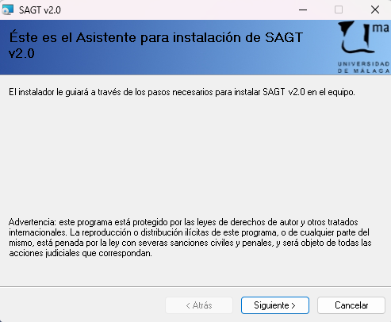
SAGT installation. Start window
To continue, click Next. The window shows the licence agreement setting out the conditions of use of the software. It is advisable to read the agreement carefully so that it is fully complied with. To continue with the installation, tick the I Agree box, by which the user undertakes to make proper use of the software and of its distribution.
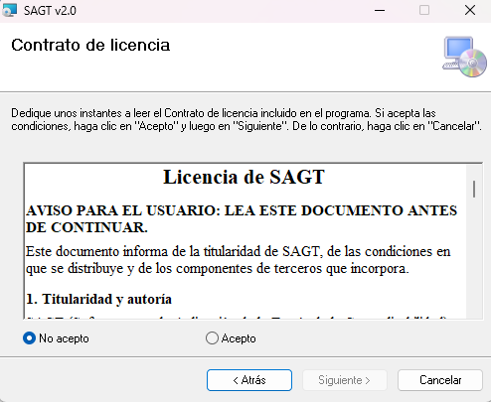
Licence agreement window
Before beginning the installation, indicate the location on the system of the destination folder in which the software will be placed. By default this is “C:\Program Files\UMA\SAGT <versión>” . You can specify whether all users will have access to the application or only the person installing it. Select Next to continue.
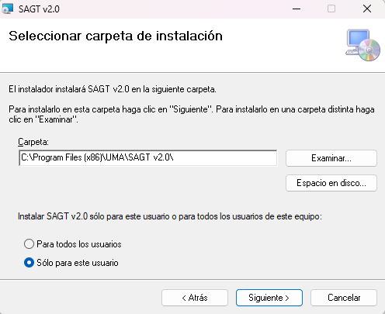
Installation folder selection window
Confirmation to install the software is then requested. Select Next to begin the installation.
A progress bar indicates the current status. When it completes, the wizard reports that the installation process has finished. To conclude, select Close.
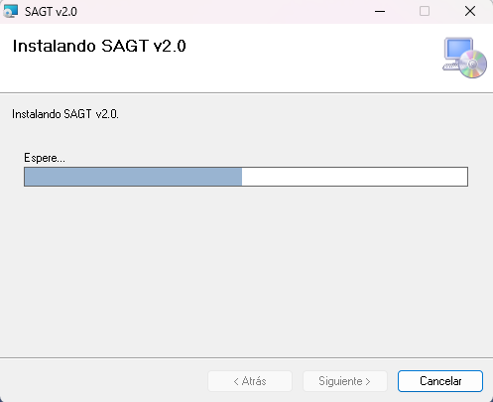
Installation progress bar

You can open the SAGT v2.0 application in two ways. By double-clicking the desktop icon or through the start menu.
SAGT icon
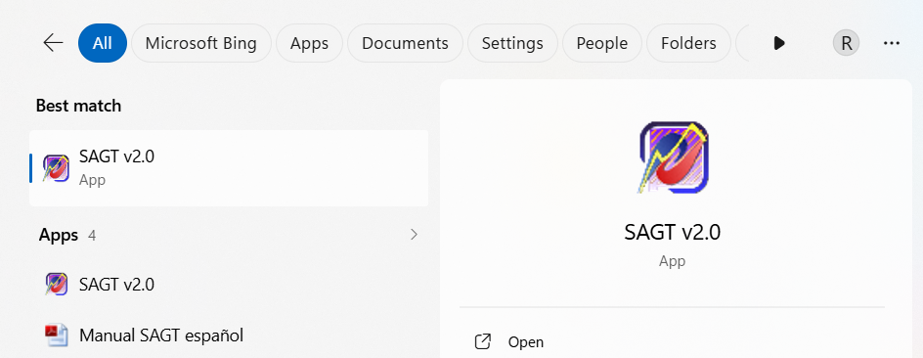
Opening the application from the Start menu (Windows 11)

2 Main menu
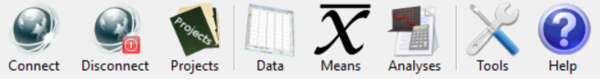
The availability of the options shown in the main menu varies according to the state of the program (whether or not it is connected to the MenPas Web service) and whether the user has the permissions needed to access them.

3 Connect/Disconnect
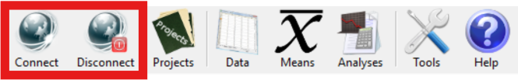
The first menu option allows connection to and disconnection from the MenPas Web service. On selecting Connect, the program asks for the user identifier and the password needed to access that service. It offers the possibility of storing the user password on the system; to do so, tick the Save password label, which is not ticked by default. After the verification process, the remote database is accessed and you can work with the data stored there as well as adding new data to the Web service database.
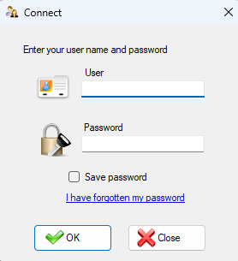
Connect window
Both the user identifier and the password must be the same as those set on the MenPas Web platform. The user must therefore register beforehand with that service in order to use the remote access capabilities of SAGT. If the password has been forgotten, the recovery protocols established on the MenPas platform apply. That option is reached by clicking the I have forgotten my password label.
Depending on the type of permission the user holds, these are the actions that can be performed:
- Administrator: Creates the project and assigns a project director, who must be a restricted administrator. Administrators can download and upload files regardless of the project. They can edit and create projects.
- Restricted administrator: Can download and upload files to the platform but only for the projects they direct. The files can be downloaded by users belonging to the same group as the restricted administrator. The administrator has access to all uploaded files regardless of group and project. Cannot create or edit projects.
- Other users: If the user belongs to a group, they can download files belonging to a project associated with that group. The association is made through the administrator, who assigns a director (restricted administrator) to the project. If that person is responsible for a group, the users belonging to that group have access to the project and therefore to the files it contains.
NOTE: Associating a restricted administrator with a group is done from the MenPas platform. For more information see the manual for that platform.

4 Projects
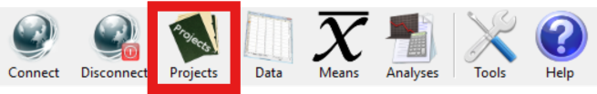
Allows the administration of projects, their assignment to different users, and the administrative tasks relating to those projects. Projects store the data contained in .sagt and .anls files, since these are the two main file types SAGT works with. Initially there is no active project, so you must create one.

4.1 Create project
Accessible only to the Administrator. Select the Create option on the Projects menu in order to enter the project data. There are only two items: the project name and its description. By default, every project is administered by the person who creates it, so that field does not need to be entered. You can assign the directorship to other users if you have system permission. Nor is it necessary to enter the creation date and time, since it is generated automatically by the system. Only users with the Administrator and Restricted administrator profiles can create projects.

4.2 Edit project
Accessible only to the Administrator. To modify an active project, click the Edit option on the Projects menu. A project cannot be edited if none is active. Confirmation is requested before a project is edited. You can change the name and edit the description. Note that a project cannot have an empty name and that it cannot be given the name of another existing project. The date cannot be modified, since it corresponds to the moment the project was created. Nor can the Project Director field be edited from the Edit option. To change the project director, use the Assign director option (see section 4.4).

4.3 Search project
Accessible to all roles but with limitations. The administrator can filter projects using search fields. Restricted administrators and users limit the search to projects belonging to their group.
To change the active project, carry out a search and select, from among the projects found, the one that will replace the current one. To do so, select Search on the Projects menu. Next, if you are an administrator, you can enter data to narrow the search, which returns the records containing the keywords. There are two search fields: the project name and its description. Once the keywords have been entered, click OK. If you are a restricted administrator or a user, a table is shown with the projects found that belong to the user's group. The first record is selected by default. Click the project and then the OK button. The active project data is updated. From then on, any document you save on the application's Web service is associated with that project. If the project sought is not found when the selection window is shown, you can close the window and edit the search fields again.
If no record meeting the conditions is found when the search is filtered, this is reported by an on-screen message and you are asked whether you want all existing projects to be shown.

4.4 Assign director
Accessible only to the Administrator. When a project is created it has no project director assigned to it. The administrator must assign one of the restricted administrators.
To assign a new project director, select the Assign director option on the Projects vertical menu. The Select window opens, showing a table with the available users and their profiles. Select in the table the user who will replace the previous project administrator, if there was one. The first is marked by default. Then press OK.

5 Generic actions
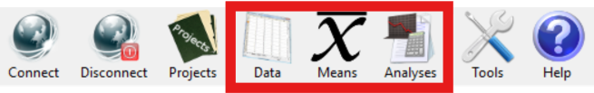
The three main sections (Data, Means, Analyses) have a number of options in common in their vertical menus and their tabs:

5.1 Save
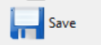
This option saves to a .sagt file the current state of the workspace across the three main sections (Data, Means, Analyses). Note that this completely replaces the current workspace. To change the default location offered when saving a file, see Tools Settings Connection.
To save the file on the MenPas Web platform and so share the study with other users, you must be registered on that platform, have an active project and hold the necessary permissions. Select Save on the vertical menu and then click Save on Web service. The window for selecting the items to be saved is shown. This is slightly different from the one for saving locally, since a text field is shown in which to enter the file name. The file to be stored on the Web service must be given a name. If a file with the same name already exists, the system warns you so that the name can be replaced by another. There is no option to overwrite files, so that information is not destroyed. Once the data to be saved has been ticked and a valid name entered, click OK. Confirmation is requested and, once accepted, the data is stored on the Web platform. This operation may take some time depending on the volume of data and the connection speed.

5.2 Open
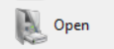
Restores the state of a workspace across the three main sections exactly as it was when it was saved.

If you have access to the MenPas platform and the necessary permissions, you can retrieve data files stored on that Web service. To do so, choose Open data file on the vertical menu and then Open from Web service. You must be connected and have an active project in order to perform this operation. A table is shown with the files belonging to the active project. Click the file data and then select OK. The data is loaded and shown in the local application. This operation may take some time depending on the volume of data and the connection speed.
Icon for .sagt files
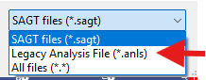
In earlier versions of the program, files with the .anls extension were more commonly used for saving. These files can still be imported by selecting ‘Legacy Analysis File (*.anls)’ from the list of extensions.

5.3 Information tabs
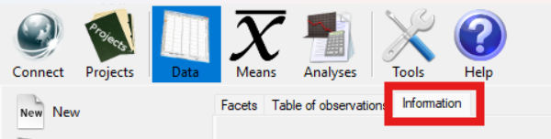
Each of the three main sections has its own information tab at the end, in which to keep notes about that particular section.
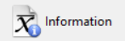
Because the Means section tends to fill up with tabs, which makes reaching the information tab from there slow, that section exceptionally has a shortcut on the vertical menu for reaching the tab quickly.
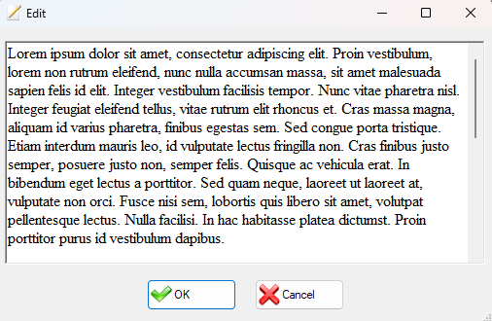
Edit window
To edit the comments, press the Edit button on the information tab. A window is then shown in which you can enter comments or make changes to text already entered.
In certain cases, when data is imported, the Information tab is filled in automatically with information relevant to interpreting the data.
In the case of the Means and Analyses sections, these tabs hold some extra data:
- The name of the original file the section's data comes from, which need not match the last .sagt file it was saved in (the data may have been obtained by importing from another application, so keeping the data consistent is the user's sole responsibility).
- The date on which the data was originally generated.

5.4 Import
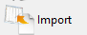
Imports data specifically related to the section from which the button is pressed. The different options available in each section are set out in the part of the manual corresponding to that section.

5.5 Reports
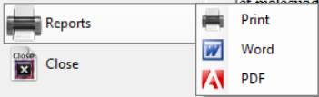
The application can generate .docx and .pdf reports, or send them straight to the printer. Select first which of the three you want and then which sections of the application you want to appear in the report.
If, for example, you only want the observations table report, tick the first box of those shown in the window and untick all the others. If no observations table is open, you cannot use this option (it is only enabled for open items).
There are several report configuration options. Tools menu Settings Reports tab.

5.6 Export Excel

SAGT exports the data of that specific section to an Excel file (.xls). Comment data is not exported. These files can then be imported back through Import in the corresponding section.

5.7 Close
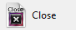
Closes all the items belonging specifically to the section where the button is pressed. The other sections keep their data.

6 Data
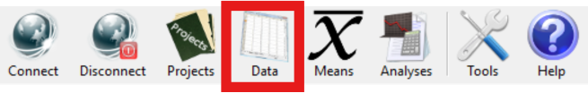
The Data option holds the observations table and data about the facets that make it up. Once created, various studies can be carried out: tables of means, analysis of variance and Generalizability study. Different options are available that make conducting the study more flexible, such as the possibility of omitting facets and levels.

6.1 Theoretical principles

6.1.1 Definition of the facets
Facets (variables) are the sources or factors of variation that form part of an overall structure in a study design, and which may be selected as objects of study within it. In this way each facet of a research design may be considered a measurement instrument or evaluation condition (facets of instrumentation) in the study of the other facets (facets of differentiation). The term facet designates each of the characteristics of the measurement situation that is liable to be modified from one observation to another and that may consequently cause the value of the result obtained to vary.
Each facet consists of:
- Name of the facet: unique for each factor of the Generalizability study. Once nestings have been carried out, its arrangement relative to other facets is also taken into account.
- Level (positive integer less than or equal to the size of universe): each of the possible scores or manifestations of a facet. For example, if the facet is Observers, each observer is a level of the facet.
- Size of universe: Refers to each of the scores or manifestations of the facets for which the researcher is interested in generalizing the results to a universe wider than that of the sample itself. “The universe of generalization is the set of conditions to which the results observed under particular conditions are to be generalized”

6.1.2 Arrangement of the facets
There are many designs for Generalizability analysis depending on the researcher's interests. Three types of design are distinguished according to their characteristics:
- Crossed or factorial: In this type of design there is at least one datum for every combination of levels of one factor with the levels of the other factors. The classic example is , in which p are the participants or persons and i are the evaluation instruments or items. This design implies that all participants are evaluated with all the chosen evaluation instruments.
- Nested or hierarchical: Consists of low-level observations nested within higher levels; in this case two conditions must be met:
  - The levels of one factor are associated with each level of another factor
  - Different levels of one factor are associated with each of the levels of another factor.
The theoretical basis underpinning the analysis of nested designs starts from the idea that all data is organised into hierarchies naturally. Example: Pupils (a) in classes (g) in schools (c): a:g:c
- Mixed or confounded: Refers to the case in which only condition a) of nested designs is met, that is, only multiple levels of one factor are associated with each level of another factor. Here the researcher cannot separate the sources of variation of some design facets, whether because of the measurement conditions or the availability of the information.
The design of the facet is given by a string in which the name of the facet appears in square brackets, the character symbolising nesting is the colon, and if one facet is crossed with another no character is used to express the relationship: they simply appear next to each other.
Examples:
Type | Design | Representation
Crossed
Nested | a:g:c | [a]:[g]:[c]
Mixed | a:() | [a]:[p][i]

6.1.3 Table of observations
The table of observations is where the empirical scores obtained by each of the factors or participants in taking the tests are recorded.
Example of a fully crossed design:
Crossed
i
j
p
Design:
$$p×i×j$$
Name | Level
Judge (j) | 2
Persons (p) | 2
Items (i) | 2

The Table of Observations could be represented as follows:

D | Judge 1 |  | Judge 2
 | Item 1 | Item 2 | Item 1 | Item 2
Person 1 | [1,1,1] = | [1,1,2] = | [2,1,1] = | [2,1,2] =
Person 2 | [1,2,1] = | [1,2,2] = | [2,2,1] = | [2,2,2] =

If all the facets are crossed, the table of observations is easy to obtain by means of the Cartesian product. The number of indices is obtained by multiplying the levels of the facets (2x2x2 = 8 indices or rows in the table of observations). In the program the table of observations looks like this:

Judge | Item | Person | Measurement variable
1 | 1 | 1
1 | 1 | 2
1 | 2 | 1
1 | 2 | 2
2 | 1 | 1
2 | 1 | 2
2 | 2 | 1
2 | 2 | 2

If the design is mixed, the number of levels of those facets that are nested is divided by the levels of the nesting facets. The number of indices or rows in the following example is therefore calculated as follows:
$$n_{p}×\left(\frac{n_{i}}{n_{j}}\right)×n_{j}=2×\left(\frac{2}{2}\right)×2=4$$
Mixed
Design: $p×(i:j)$
i
j
p
Name | Level
Judge (j) | 2
Persons (p) | 2
Items (i) | 2

The Table of Observations could be represented as follows:

 | Judge 1 | Judge 2
 | Item 1 | Item 2
Person 1 | [1,1,1] = | [2,1,2] =
Person 2 | [1,2,1] = | [2,2,2] =

Mixed
Design: $p×(i:j)$
i
j
p
Name | Level
Judge (j) | 2
Persons (p) | 2
Items (i) | 4

The number of indices would be calculated as: $n_{p}×\left(\frac{n_{i}}{n_{j}}\right)×n_{j}=2×\left(\frac{4}{2}\right)×2=8$
The Table of Observations could be represented as follows:

 | Judge 1 |  | Judge 2
 | Item 1 | Item 2 | Item 3 | Item 4
Person 1 | [1,1,1] = | [1,1,2] = | [2,1,3] = | [2,1,4] =
Person 2 | [1,2,1] = | [1,2,2] = | [2,2,3] = | [2,2,4] =

Nested
Design: $p:i:j$
i
j
p
Name | Level
Judge (j) | 2
Persons (p) | 2
Items (i) | 4

The Table of Observations might be represented as follows:

 | Judge 1 |  | Judge 2
 | Item 1 | Item 2 | Item 3 | Item 4
Person 1 | [1,1,1] = | [1,1,2] =
Person 2 |  |  | [2,2,3] = | [2,2,4] =

To build the table of observations the program always performs a Cartesian product of the levels of the facets in the study. Unbalanced designs with multiple observations per cell are not fully supported. A known cell may be left without any observation, but the program's calculations are not designed for that. Consider whether it is appropriate to interpret null cells automatically as zero (see section 9.1.1).

6.2 Creating the table of observations
To create the table of observations, select the New option on the Data vertical menu.
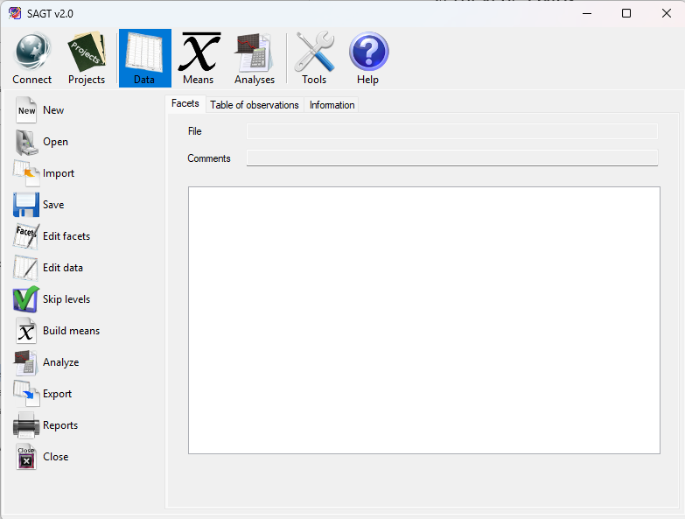
Data option
The window opens in which you must enter the number of facets the variability study will consist of. The number of facets cannot be modified once the study has begun, so it must be entered correctly at the outset.
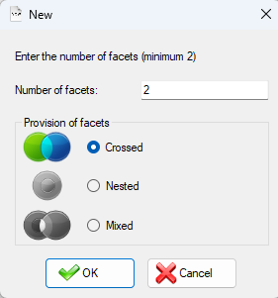
New window
The window has a box showing the arrangement of the facets in the study: Crossed (the default), Nested or Mixed. If the nested facet arrangement has been chosen, nesting is carried out automatically, following the criterion explained below. If Mixed is selected, you have complete freedom to create any type of model, including fully crossed and fully nested ones.
Once the number and arrangement of the facets have been indicated, a text box appears in which a short comment may optionally be entered, together with a table in which each row corresponds to one of the facets. The attributes of each facet are as follows:
- Name (required): Name of the facet. It consists of numbers and letters, which may be separated by the space character.
- Level (required): Positive integer.
- Size of universe (optional): Must be greater than or equal to the level of the facet entered. If this field is left empty it is filled in automatically with infinity (“INF”). To state formally that the size is infinite, press the ‘i’ key and the field is filled in automatically showing infinity.
- Description (optional): A short description of the facet.
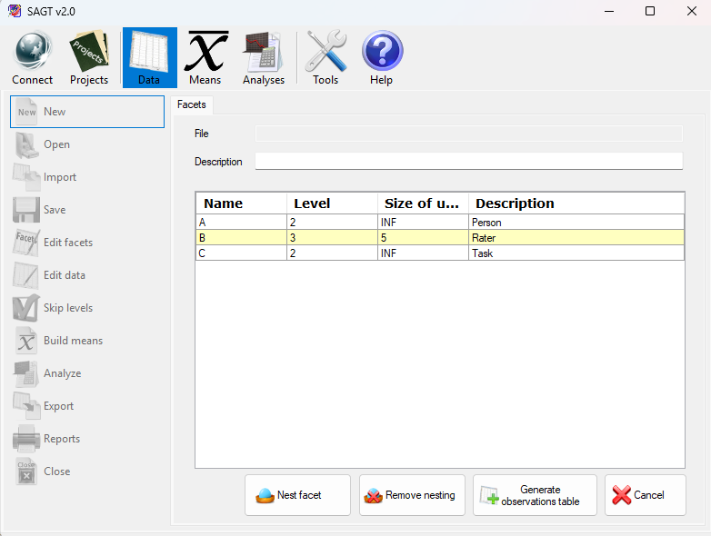
Facet editing
If the Crossed or Nested design type has been selected, only the Generate observations table and Cancel buttons appear. If the Mixed design type has been selected, the Nest facet and Remove nesting buttons also appear, allowing the arrangement of each of the facets to be entered.
Once the facets have been entered and their arrangement indicated, all that remains is to press the Generate observations table button. The table of observations appears and you can enter the observed data. Note that the indices of the table of observations follow the same order in which the facets were entered.
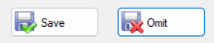
Once the data has been entered, you can complete the operation by selecting the Save button. A new tab opens in which, if Save is selected again, you must enter the name and location of the file on the computer. You can also select the Omit option if you do not want to save a file at this point. If, on the other hand, you choose Cancel, the data entered in both the table of observations and the facets table is lost.
If the Nested facet arrangement was chosen when entering the number of facets, the facets are distributed automatically on pressing the Generate observations table button. Nesting is carried out in descending order, with each facet nested within the facets that come after it in the table.
For example, for the following facets the automatic nesting produced would be as follows:
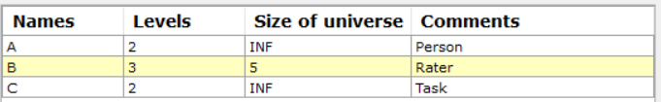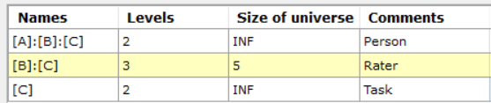
C
B
A
Entering facets
Resulting facets table
Graphical representation
The table of observations corresponds to the Cartesian product of the levels of the facets. The design of the facet also appears in the heading of the table columns corresponding to the indices. The last column is that of the measurement variable. At most one observation per row is allowed.
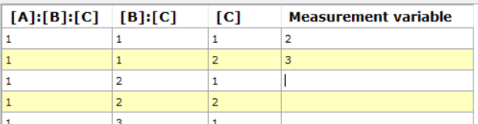
Heading of a table of observations

6.2.1 Import scores
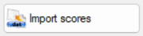
SAGT can import scores from a text file to fill in the table of observations. Files of this type are usually compatible with most statistical calculation programs such as SPSS, SAS, Matlab, EduG 6.0, etc. All that is needed is for the data to be separated by the space character or arranged one per line. The values in the table are replaced by the data in the file as long as there is data that can be assigned. When the import finishes, a message is shown with the number of data items entered into the table of observations out of the total number of data items in the file. If there is less data than the table of observations holds, the remaining values are not modified and keep whatever value was already set.

6.3 Arrangement of facets in mixed designs
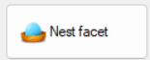
If the mixed design has been selected, the nestings must be entered manually. If no nesting has been entered, this corresponds to fully crossed facets. To carry out nestings, select the Nest facets button. Confirmation is requested before the nesting process begins, since once nesting processing has started the facets table can no longer be edited nor its attributes modified.
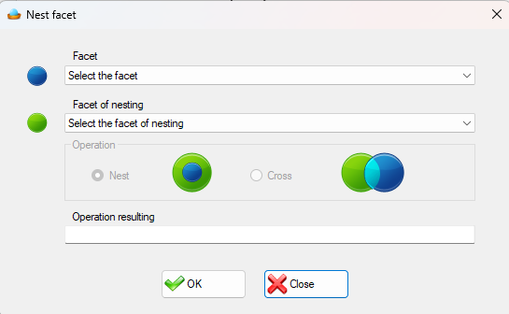
The Nest facet window contains two tabs. The first, the upper one, allows you to select from among all the facets the one that is to be contained within another facet. On the lower tab, select the nesting or containing facet. Once the first nesting has been made, the operation box is enabled, in which you can choose the type of operation to be performed on the selected facets. The operations are Nest and Cross. The window shows a text box in which you can observe the resulting operation.
Nest facets window
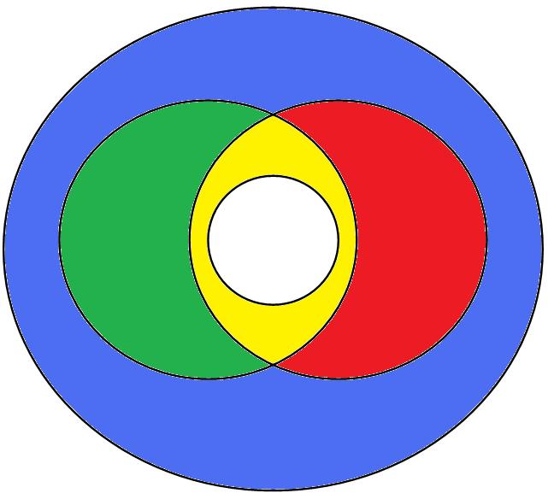
Example:
A
B
C
D
The facet arrangement shown in the figure applies. Facet ‘D’ nests all the other facets, where ‘B’ and ‘C’ are crossed. Both in turn nest facet ‘A’. The steps for building it could be the following (since the order of the nestings does not matter):
- Nest A in B [A]:[B]
- Cross A:B with C [A]:[B][C]
- Nest C in D [C]:[D]
- Nest B in D [B]:[D]
After which the Facets table looks like this:
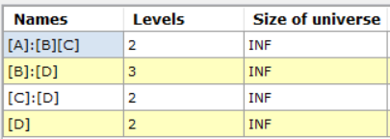
Facets table belonging to the mixed example
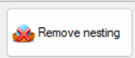
To undo any of the nestings, click the Remove nesting button. A window is shown with the list of nestings. Mark with a mouse click all the nestings you want to remove. Finally, press the delete button in that window, which updates the contents of the facets table and removes the selected nestings. As long as the table of observations has not been generated, you can go on modifying the arrangement of the facets in the design.
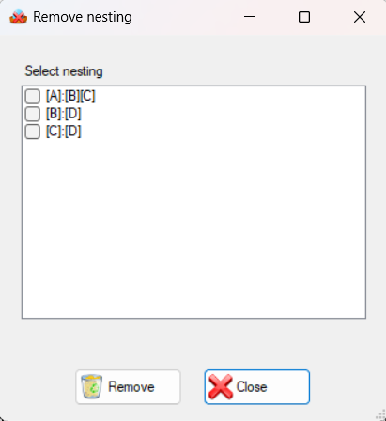
Remove nesting window

6.4 Edit facets
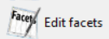
Allows the names, levels, sizes of universe, comments and nestings of the facets to be modified.
Once Edit is selected, the facets appear with their nesting undone, ready to be redone.
Levels are a special case, since editing them directly affects the table of observations. If levels are increased, new levels with null observations are added after the last ones of those facets. If they are decreased, levels are removed starting from the last. The observations of those levels are permanently deleted. If you later want to restore those levels, use the Skip levels feature instead.

6.5 Edit table of observations
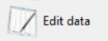
Allows the values of the observed variable in the table of observations to be modified. It also allows the same import of scores as when creating the table of observations.

6.6 Omit facets
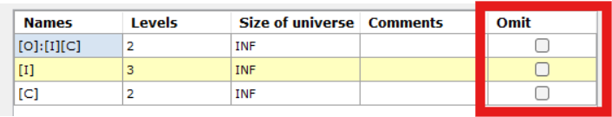
Omitting facets from a study means using in the calculations a table of observations that does not have that column and that distributes its observations by means of arithmetic means. The result can be seen in the Means section after selecting Build means.
To exclude facets from the study, simply tick in the facets table those you need to omit. You can omit one or more facets, but there must always be a minimum of two for the Generalizability study to be carried out.

6.7 Skip levels
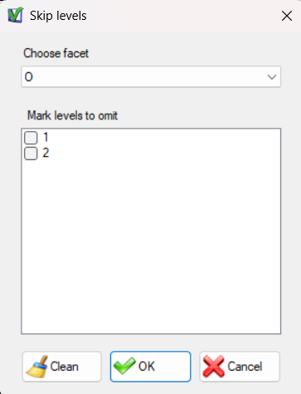
Skip levels window
Omitting a level from a study means that its facet has one level fewer as far as the calculations are concerned, and that the level excluded from the calculations is precisely that one.
To skip levels, select the Skip levels option on the vertical menu. A window appears with a drop-down tab in which you can select the facet whose levels you want to omit. Below the drop-down tab a text box appears in which you can tick the boxes of the levels you want to exclude from the study.
Press the Clean button to untick all the boxes of the current facet.

6.8 Hide null values
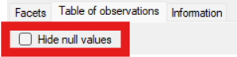
On the table of observations tab, Hide null values is a purely visual tool for hiding every row with a null value when you want to inspect the non-null data in particular. It does not affect the calculations.

6.9 Import data
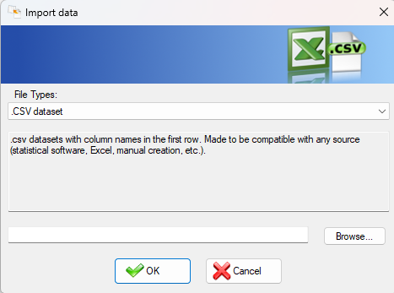
Import data window
SAGT can import data from files generated by different applications in order to build a table of observations from them. To do so, select the Import data option on the vertical menu. A window is shown in which you must first select the file type and then locate it with the Browse... button.
The importable file types are the following:
- Observations file (.obs) GT E 2.0 (Pierre Ysewijn, 1996): For this, the data file (.dat) must be in the same location as the observations file (.obs), since that program stores the facet data and the observations in separate files.
- Result of means (.rsm) GT E 2.0 (Pierre Ysewijn, 1996): Reconstructs the table of observations from a file of means. When the GT program generates the table of means it does so for all combinations of facets, so the last table of means always coincides with the table of observations.
- Observations table exported to Excel (.xls): Imports the data from an Excel file exported by the SAGT application.
- Comma-separated values (.csv): Imports a table of observations from essentially any statistical application.
The CSV importer has a special interface that lets the user 1. Select which is the measurement variable (if it is not the last one) 2. Leave columns behind (which are interpreted as extra measurement variables that are not used. They are not spread as an arithmetic mean across the remaining facets. To do that, import those columns and then use the Omit facets feature). The program records the chosen measurement variable in the Description field of the Facets tab.
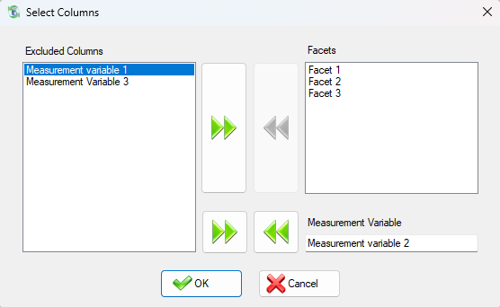
Select Columns window in use
In addition, since other programs can identify levels by text and the program cannot, the Information tab is filled in automatically with the numerical identification assigned to each level of each facet.
For example, for the following imported file (Gender and Region imported as facets, Score as the measurement variable):

census.csv
"Gender","Region","Score"
"F","North","30.15"
"F","South","10"
"M","North","30"
"M","South","70"

The following table of observations is generated:
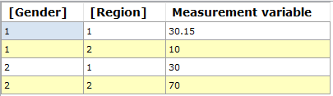
And the following information tab:
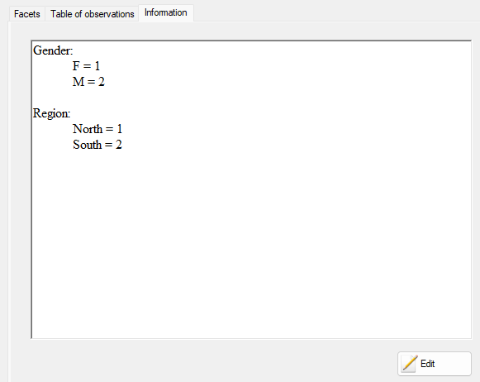
No size-of-universe or nesting data is imported, so these are interpreted by default as infinite and fully crossed. Both can be edited through the Edit facets option on the vertical menu.

6.10 Build means
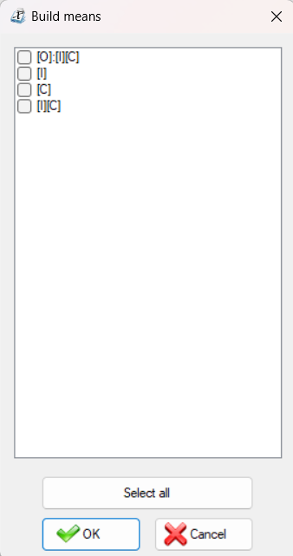
Build means
To carry out a study of means from the tables of observations, select Build means on the vertical menu. A window appears showing all the possible combinations of facets according to the arrangement assigned. Tick the boxes of the designs you want to study. There is a button for selecting all the boxes shown in the window; pressing that button again unticks them all. Once the selection process has finished, press the OK button and the tables of means are generated automatically.

6.11 Analyze
To generate the sums-of-squares analysis tables, select the Analyze option on the vertical menu. The measurement design window appears, with two boxes: one initially empty that will hold the facets of differentiation, and another that initially contains all the facets and that marks the facets of instrumentation. Using the move buttons you can place the facets in one group or the other. Once the facets have been arranged for the study, you only have to click the OK button and the analysis tables are generated.
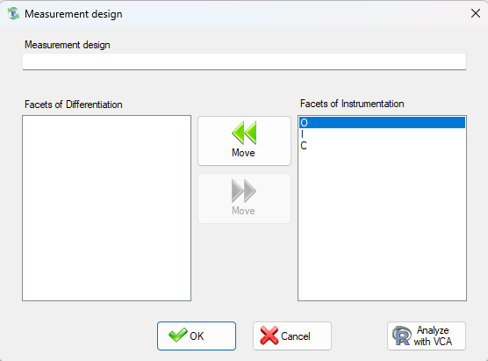
Measurement design window

6.11.1 Analyze with VCA
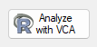
Although the program accepts unbalanced designs, with observations that may be left null, its calculations are not designed for them. Within the Analyze option you may optionally use R's VCA library for accurate calculations on unbalanced designs, in exchange for assuming that all facets are infinite random ones (infinite size of universe). An installation of R is not required, since the application comes with one already included.

6.12 Export scores
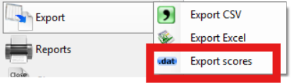
SAGT can dump the values of the measurement variable into a text file. The values are stored one per line of text. Null values are stored as zeros, so that the resulting file is compatible with other calculation programs such as EduG 6.0, SPSS, SAS, Matlab or Scilab.

6.13 Export CSV
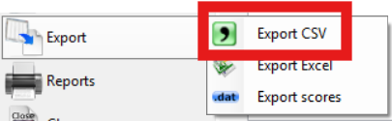
Exports the table of observations to a .csv file readable by essentially all statistical software. This is the preferred option for passing data to other applications.

7 Means
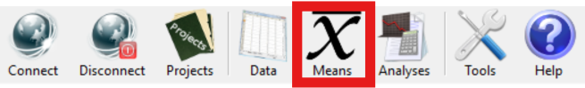
The Means option allows the study of various statistical values calculated from a table of observations. There are three types of tables of means that can be generated from the table of observations. To find out which, see section 6.10.

7.1 Types of tables of means
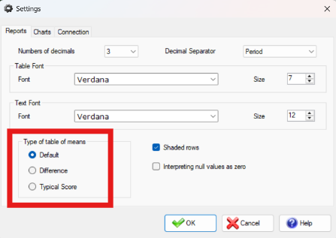
There are three types of tables of means, which can be selected in Tools Reports Type of table of means:
- The default tables, which calculate the mean, variance and standard deviation.
- Tables of difference of means calculate three columns in addition to those already mentioned in the default option. These are: the difference between the mean column and the Grand Mean, the variance and the general variance, and finally the standard deviation and the general standard deviation.
- The typical score table calculates the columns of the default table, plus the difference-of-means column and the typical scores column: [(Mean – Grand Mean) / standard deviation].
The type of means only applies when generating means data. It cannot be applied retrospectively to data already loaded.

7.2 Import means
SAGT can import tables of means from different applications. To do so, select the Import option on the vertical menu. A window is shown in which you must first select the file type and then locate it with the Browse... button.
The importable file types are the following:
- Result of means (.rsm) GT E 2.0 (Pierre Ysewijn, 1996): Reconstructs the table of means from a result-of-means file. Depending on the type of table of means selected on the Reports tab of the configuration options, it can calculate additional data such as the difference-of-means or typical-score column.
- Report of means (.rtf, .txt) EduG 6.0: Regardless of whether the report was generated with the English or the French version of the EduG program, the tables of means can be recovered from that report. If the document contains more than one report, a list of the reports it contains is shown. Choose the report you want to display. Again, depending on the type of report selected, additional information is shown.
NOTE: To guarantee that the information can be recovered correctly, the data must not have been edited by the user.
- Tables of means exported to Excel (.xls): Imports the data from an Excel file exported by the SAGT application.

8 Analyses
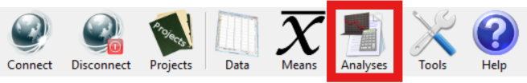
The Analyses option allows the study of the sums-of-squares tables and the variance components, the calculation of G-Parameters, the Generalizability coefficients and the estimation of those coefficients with new levels for the study facets.

8.1 Tabs
The definitions and formulae given in this section follow Brennan, R. L. (2001), Generalizability Theory, Statistics for Social and Behavioral Sciences, New York, Springer-Verlag. The references accompanying each expression refer to the corresponding section of that work.

8.1.1 Sum of squares
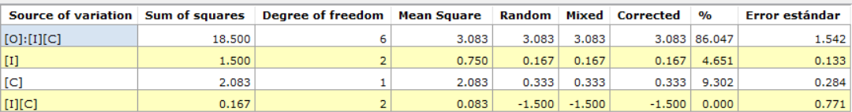
Contains data relating to the analysis of variance.
Sum of squares: refers to the “sum of squares of the deviations with respect to the mean of the observed scores”. It is calculated from partial squares. Example for the design: $o×\left(i:c\right)$:
Source of variation $α$ | Term $T\left(α\right)$ | Sum of squares $SS(α)$
 | $$n_{i}n_{h}\sum{{\bar{X}}_{o}^{2}}$$ | $$T\left(o\right)-T\left(μ\right)$$
 | $$n_{o}n_{i}\sum{{\bar{X}}_{c}^{2}}$$ | $$T\left(c\right)-T\left(μ\right)$$
 | $$n_{o}\sum{\sum{{\bar{X}}_{oc}^{2}}}$$ | $$T\left(oc\right)-T\left(o\right)-T\left(c\right)+T\left(μ\right)$$
 | $$n_{o}\sum{\sum{{\bar{X}}_{i:c}^{2}}}$$ | $$T\left(i:c\right)-T\left(μ\right)$$
 | $$\sum{\sum{\sum{{\bar{X}}_{oi:c}^{2}}}}$$ | $$T\left(oi:c\right)-T\left(oc\right)-T\left(i:c\right)+T\left(h\right)$$
μ | $$\frac{1}{n_{o}n_{i}n_{c}}{\left(\sum_{oic}{x}\right)}^{2}$$
Source: Brennan (2001), § 3.3.2.
Degree of freedom: An estimator of the number of independent categories or variables in a system of variables or in a particular test or statistical experiment.
$$df\left(α\right)=\left\{product of \left(n-1\right)s for primary indices\right\}$$
$$*$$
$$\{product of n^{'}s for nesting indices \}$$
Where $n$ refers to the level.
Example of the calculation of the degree of freedom for the design :
df $\left(p\right)=n_{p}-1$
df $\left(h\right)=n_{h}-1$
df $\left(ph\right)=(n_{p}-1)(n_{h}-1)$
df $\left(i:h\right)=n_{h}(n_{i}-1)$
df $\left(pi:h\right)=n_{h}(n_{p}-1)(n_{i}-1)$
Source: Brennan (2001), § 3.3.2.
Mean Square: obtained by dividing the sum of squares by the respective degrees of freedom for that source of variation.
$$MS\left(α\right)=\frac{SS(α)}{df(α)}$$
Source: Brennan (2001), § 3.3.2.
Random: refers to the “random variance component”. The scores obtained are assumed to carry the “confounding” of the error caused by fluctuations of the other facets while the measurements themselves were taken. These are therefore errors of a random character that are confounded with the actual measurement. They are the variances that would have been obtained for the effects sought had all possible observations been available.
The program uses the following algorithm to calculate them:
[ combination of squares of the means] ;
where has been defined as the product of the levels of , made up of those indices belonging to the total set of facets in the design that are not included in , and the appropriate combination of squares of the means is obtained as follows:
Step 0: $MS\left(α\right)$
Step 1: Subtract the mean squares of all the components containing the indices of plus one further index belonging to the design not included in ;
Step 2: Add the mean squares of all the components containing plus two indices belonging to the design that have not been included in , on condition that they were used in Step 1;
Step j: Add (if j is even) or Subtract (if j is odd) the mean squares of all the components containing the indices of plus j further indices belonging to the design that have not been included in , on condition that they were used in Step (j-1).
Example: Random Variance Components from the Mean Squares estimated for the design
Source of Variation | Estimate of the random variance component
 | $$\frac{1}{n_{i}n_{h}}\left[MS\left(p\right)-MS\left(p:h\right)\right]$$
 | $$\frac{1}{n_{p}n_{i}}\left[MS\left(h\right)-MS\left(i:h\right)-MS(ph)+MS(pi:h)\right]$$
 | $$\frac{1}{n_{i}}\left[MS\left(ph\right)-MS\left(pi:h\right)\right]$$
 | $$\frac{1}{n_{p}}\left[MS\left(i:h\right)-MS\left(pi:h\right)\right]$$
 | $$MS\left(pi:h\right)$$

Source: Brennan (2001), § 3.4.4.
Mixed: refers to the “mixed variance component”, that is, adjusted to be more accurate in the case of mixed facets (finite size of universe, but greater than the level).
$${\hat{σ}}^{2}\left(α|M\right)={\hat{σ}}^{2}\left(α\right)+\sum{\frac{{\hat{σ}}^{2}\left(βj\right)}{F\left(βj\right)}}$$
Where
${\hat{σ}}^{2}\left(α|M\right)$ = estimate of the variance component in the mixed model.
${\hat{σ}}^{2}\left(α\right)$ = estimate of the variance component in the random model.
${\hat{σ}}^{2}\left(βj\right)$ = every component, except , whose index contains all the facets of .
$F\left(βj\right)$ = product of the number of universe levels for the indices of that do not appear in .
If all the effects are distributed at random in a supposedly infinite universe, the ratio $\frac{{\hat{σ}}^{2}\left(βj\right)}{F\left(βj\right)}$ then vanishes and ${\hat{σ}}^{2}\left(α|M\right)$ = ${\hat{σ}}^{2}\left(α\right)$.
Example for the design :
Mixed Variance Components ${\hat{σ}}^{2}\left(α|M\right)$ | Estimate of the mixed variance components from the random variance components ${\hat{σ}}^{2}\left(α\right)$
$${\hat{σ}}^{2}\left(o|M\right)$$ | $${\hat{σ}}^{2}\left(o\right)+\frac{1}{N_{i}}{\hat{σ}}^{2}\left(oi\right)+\frac{1}{N_{c}}{\hat{σ}}^{2}\left(oc\right)+\frac{1}{N_{i}N_{c}}{\hat{σ}}^{2}\left(oic\right)$$
$${\hat{σ}}^{2}\left(i|M\right)$$ | $${\hat{σ}}^{2}\left(i\right)+\frac{1}{N_{o}}{\hat{σ}}^{2}\left(oi\right)+\frac{1}{N_{c}}{\hat{σ}}^{2}\left(ic\right)+\frac{1}{N_{o}N_{c}}{\hat{σ}}^{2}\left(oic\right)$$
$${\hat{σ}}^{2}\left(c|M\right)$$ | $${\hat{σ}}^{2}\left(c\right)+\frac{1}{N_{i}}{\hat{σ}}^{2}\left(ic\right)+\frac{1}{N_{o}}{\hat{σ}}^{2}\left(oc\right)+\frac{1}{N_{o}N_{i}}{\hat{σ}}^{2}\left(oic\right)$$
$${\hat{σ}}^{2}\left(oi|M\right)$$ | $${\hat{σ}}^{2}\left(oi\right)+\frac{1}{N_{c}}{\hat{σ}}^{2}\left(oic\right)$$
$${\hat{σ}}^{2}\left(ci|M\right)$$ | $${\hat{σ}}^{2}\left(ci\right)+\frac{1}{N_{o}}{\hat{σ}}^{2}\left(oic\right)$$
$${\hat{σ}}^{2}\left(oc|M\right)$$ | $${\hat{σ}}^{2}\left(oc\right)+\frac{1}{N_{i}}{\hat{σ}}^{2}\left(oic\right)$$
$${\hat{σ}}^{2}\left(oic|M\right)$$ | $${\hat{σ}}^{2}\left(oic\right)$$

Source: Brennan (2001), § 3.5.3.
Corrected: refers to the “corrected variance component”, that is, adjusted for fixed facets (level = size of universe). It applies only when all the facets of the source are fixed; otherwise it equals the mixed variance component. It is calculated by multiplying the mixed variance component by the expectation of the variance $\frac{(N_{j}-1)}{N_{j}}$ (terminology used in the doctoral thesis of Joann Lynn Moore) for each of the facets of the source of variation, where N is the size of the universe.
Example for the design :
Corrected Variance Components $c{\hat{σ}}^{2}\left(α|M\right)$ | Estimate of the corrected variance components from the mixed variance components ${\hat{σ}}^{2}\left(α|M\right)$
$$c{\hat{σ}}^{2}\left(o|M\right)$$ | $$\frac{\left(N_{o}-1\right)}{N_{o}}{\hat{σ}}^{2}\left(o|M\right)$$
$$c{\hat{σ}}^{2}\left(i|M\right)$$ | $$\frac{\left(N_{o}-1\right)}{N_{o}}{\hat{σ}}^{2}\left(i|M\right)$$
$$c{\hat{σ}}^{2}\left(oi|M\right)$$ | $$\frac{\left(N_{o}-1\right)\left(N_{i}-1\right)}{N_{o}N_{i}}{\hat{σ}}^{2}\left(oi|M\right)$$

%: Refers to the percentage of the variance, that is, the following calculation, reporting how much the component of this particular source contributes to the sum of corrected variance components (bounded below at zero):
$$\%\left(i\right)=100\frac{max⁡\{c{\hat{σ}}^{2}\left(i|M\right), 0\}}{\sum_{xϵα}{max⁡\{c{\hat{σ}}^{2}\left(x|M\right), 0\}}}, iϵα$$
Standard error: calculated as follows:
$$\hat{σ}[{\hat{σ}}^{2}\left(α|M\right)]= \sqrt{\sum_{β}{\frac{2{\left[f\left(β | α\right)MS\left(β\right)\right]}^{2}}{df\left(β\right)+2}}}$$
Where:
$β$ = component whose mean square is used in the calculation of ${\hat{σ}}^{2}\left(α\right)$
$f\left(β | α\right)$ = coefficient by which that mean square is multiplied in the linear combination of mean squares with which ${\hat{σ}}^{2}\left(α\right)$ is calculated
Source: Brennan (2001), § 6.1.1.

8.1.2 G-Parameters
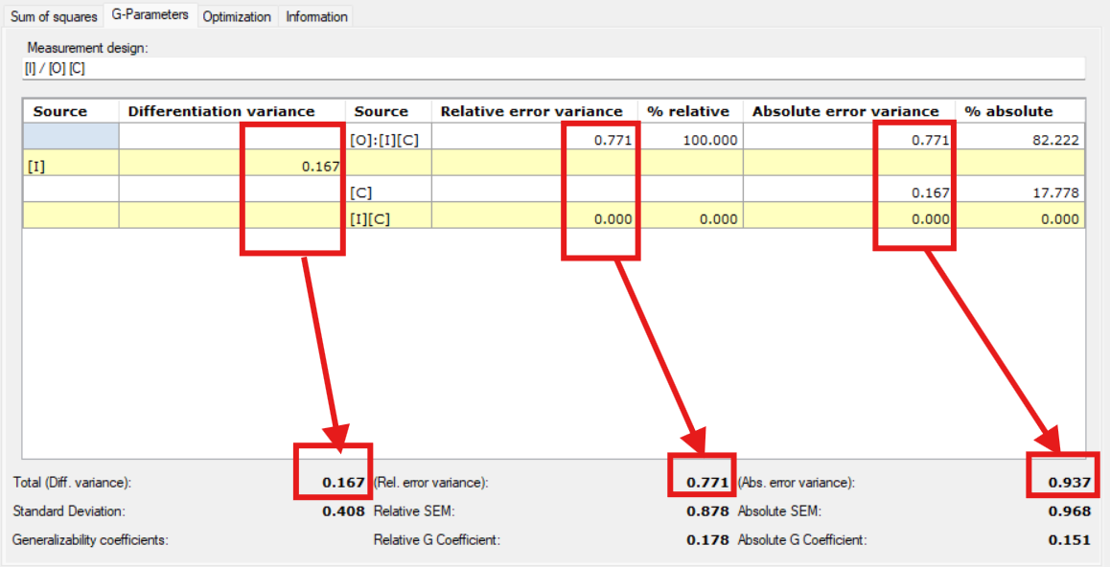
The differentiation, relative error and absolute error variances are shown in the parameters below. The numbers in the column represent the contribution of that source to the parameter in question.
Source (of differentiation): Each of the sources that produce the differences we are interested in; it may be any of the facets studied, on which the measurement is performed.
Differentiation variance: $σ^{2}\left(τ\right)$, applies to sources of differentiation.
Source (of instrumentation): Also called sources of generalization, these are the remaining sources that make up the study and that constitute the sources of error on the measurement facets.
Relative error variance: Relative error may be defined as the “error about the relative mean” ($σ(δ)$); it is the error made when estimating the deviation between the observed score and the mean of the score, in the corresponding “population” of objects of the study. When this type of analysis is carried out in psychology, and more specifically in observational psychology, the decisions taken are relative to the study, so this type of error is the most appropriate in most cases.
Absolute error variance: Cronbach describes the “error about the absolute mean” ($σ(Δ)$) as the deviation of the observed value with respect to the universe score, that is, the universe of the possible scores of a factor. Absolute measurement is spoken of when a magnitude is to be placed with respect to a scale whose steps have been defined a priori, even before the observations have been made.
All sources of differentiation contribute to the absolute error. They contribute to the relative error only when they contain some facet of differentiation. For the rest, their cells corresponding to the relative error are left empty (Brennan, 2001, § 1.1.2, “Error Variances”).
In either case, the contribution is the same value, the Decision Study variance component of that source, which is calculated with the following function and anchored at 0 if it turns out negative:
$$σ^{2}\left(\overline{α}|M'\right)]=\frac{C\left(\overline{α} | τ\right)}{d(\overline{α}|τ)}[\sum{\frac{K^{'}\left(β | α\right)}{\prod^{'}{\left(β | α\right)}}}{cσ}^{2}(β|M)]$$
Where:
$τ$ = Facets or sources of differentiation
$d(\overline{α}|τ)$ = 1 if $\overline{α}$ = $τ$, and otherwise the product of the levels for every index in $\overline{α}$ except those that are in $τ$
$C\left(\overline{α} | τ\right)$ = Finite population corrector. 1 if $\overline{α}$ = $τ$, and otherwise the product of the terms $\frac{N^{'}-n'}{N^{'}-1}$ for the primary indices (not nesting any other in this source) in $\overline{α}$ except those that are in $τ$.
$N^{'}$ = New size of universe (if it has been changed; otherwise it equals $N$).
$β$ = Every source containing all the indices in $α$
$\prod^{'}{\left(β | α\right)}$ = The product of the $N^{'}$ of all the indices in $β$ that are not in $α$. It equals 1 if $α= β$ .
$K^{'}\left(β | α\right)$ = Product of the terms ${(1-\frac{N}{ N}}^{'})$ for all the primary indices in $β$ that are not in $α$. It equals 1 if $α= β$ .
Source: Brennan (2001), § 5.1.1, eq. (5.6); a more accurate finite population corrector is used, calculated specifically for this case.
If this calculation turns out negative, it is anchored at 0, following Brennan (2001), § 3.4.6, on negative variance components.
Relative SEM and Absolute SEM: correspond to the relative and absolute standard error of measurement respectively. They are calculated from the square root of the relative and absolute error variance respectively.
Generalizability coefficients: The Generalizability coefficient is the degree to which the measurement taken with a test is representative of all possible measurements, that is, how far one can generalize from a particular measurement to the rest of the possible measurements. Reliability studies whether a test is suitable for a particular situation, whereas generalizability studies whether that suitability extends to the greatest possible number of situations. It takes values between 0 and 1, expressing the degree to which a given measurement can be generalized to the whole population of possible measurements contemplated in the research design. It is defined as the proportion of the total variance corresponding to the true variance.

Absolute G Coefficient | $$Eρ^{2}\left(Δ\right)=\frac{σ^{2}\left(τ\right)}{σ^{2}\left(τ\right)+σ^{2}\left(Δ\right)}$$
Relative G Coefficient | $$Eρ^{2}\left(δ\right)\frac{σ^{2}\left(τ\right)}{σ^{2}\left(τ\right)+σ^{2}\left(δ\right)}$$

8.1.3 Optimization
This tab is reserved for calculations relating specifically to Decision Studies. See section 8.6.

8.2 New sum of squares
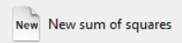
To skip doing the calculations from a table of observations and use sums of squares already calculated, select the New sum of squares button on the vertical menu. As when generating the table of observations, you must indicate the number of facets and the type of facet arrangement of the study (see section 6.2).
Once the facet data has been entered, enter the measurement design of the study, indicating which are the facets of instrumentation and which the facets of differentiation (see section 6.11).
Finally, enter the value of the sums of squares. Alternatively, the data can be imported from several types of file.
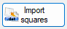
Import squares allows only the squares to be imported, from .dat or .edug files:
- The .dat files contain sums of squares separated by spaces, or else each value is on a separate line of text.
- The .edug files have a format compatible with the EduG 6.0 application, namely a comma-separated file (the ‘;’ character is the separator). It contains three columns. The first column holds the facet design, the second the sum of squares and the third and last the degree of freedom.
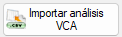
Import VCA analysis allows the ‘aov.tab’ field to be imported from the result of an anovaVCA operation of the VCA library (version 1.5.2) whose nestings and facet names match those already entered in the study, both the squares and further relevant calculations. This is a more manual and more customisable alternative to the Analyze with VCA feature.
An example of a script that would meet the requirements is:

script.R
# Import
dat <- read.csv("ExportedFromSAGT.csv") # Contains facets ‘i’ and ‘p’

# design i nested within p
fit <- anovaVCA(
Measurement.Variable ~ p + i:p,
Data = dat
) # Measurement.Variable ~ p/i also works.
# Whether we write ‘i:p’ or ‘p:i’ does not matter, they are interchangeable.
# note: sources of variation with more interactions (i:p in this case) must be written last. Otherwise it breaks.

# Export results
write.csv(fit$aov.tab, "Raov.csv")

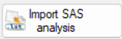
Import SAS analysis imports a SAS .lst report from a GLM procedure, more specifically the first table of the following type found in the report. The nestings and facet names in the report must match those already entered in the study.
Report.lst
[…]

Mean
Source DF Type I SS Square F Value Pr > F

p 1 220100.3221 220100.3221 102.33 <.0001
i 9 764936.8150 84992.9794 39.52 <.0001
p*i 5 223305.2764 44661.0553 20.76 <.0001
e 1 154625.1987 154625.1987 71.89 <.0001
p*e 1 31959.3724 31959.3724 14.86 0.0004
i*e 9 85302.1447 9478.0161 4.41 0.0004
p*i*e 5 7747.0805 1549.4161 0.72 0.6118

[…]

After saving the data to a file, the analysis tables are generated: variance components, G-Parameters and data summary.

8.3 Edit
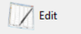
Gives access to the same data entry screen available during creation.
Changes to nestings are not allowed, since this would affect the sum of squares, causing new sums of squares to appear or existing ones to disappear. That feature is available only in the Data section.
After an edit, the calculations on the Sum of squares and G-Parameters tabs are updated, except for the summaries on the Optimization tab, which are removed unless the edit involves only names and descriptions.
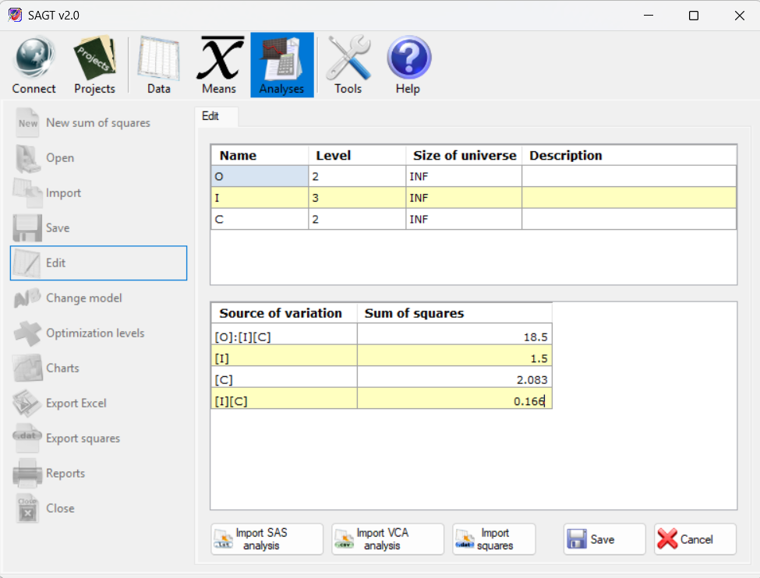
Edit analysis

8.4 Change model
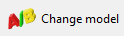
Allows the measurement design entered in a model to be changed. A selection window is shown in which you must indicate the facets of instrumentation and of differentiation. Once finished, the changes are applied to the G-Parameters table.
The calculations on the Sum of squares and G-Parameters tabs are updated, except for the summaries on the Optimization tab, which are removed.

8.5 Import analysis
SAGT can import analysis-of-variance tables from different applications. To do so, select the Import option on the vertical menu. A window is shown in which you must first select the file type and then locate that file with the Browse... button.
The importable file types are the following:
- Sum of squares (.ssq) GT E 2.0 (Pierre Ysewijn, 1996): reconstructs the information from a file containing the sum of squares.
- Result of sums-of-squares analysis (.rsa) GT E 2.0 (Pierre Ysewijn, 1996): Obtains the data of the analysis tables as well as any data obtained from the level estimation process carried out with the GT application.
- Report of means (.rtf, .txt) EduG 6.0: Regardless of whether the report was generated with the English or the French version of the EduG program, the sums-of-squares analysis tables can be recovered from that report. If the document contains more than one report, a list of the reports it contains is shown. Choose the report you want to display. Again, depending on the type of report selected, additional information is shown.
NOTE: To guarantee that the information can be recovered correctly, the data must not have been edited by the user and, when recovering a .txt report, the facet labels must not be longer than 25 characters, since a longer label would be split across several lines and would cause ambiguity when reading the file.
- Tables of means exported to Excel (.xls): Imports the tables from an Excel file exported by the SAGT application.

8.6 Optimization levels
Carries out a Decision Study, using variance components calculated previously but with different levels and/or universes. Enter the values you want in the corresponding cells.
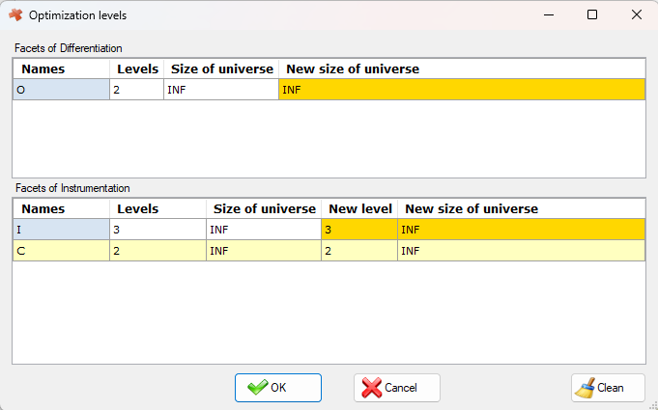
Optimization levels window
The newly estimated parameters are added to the lower table of the Optimization tab as a new column.
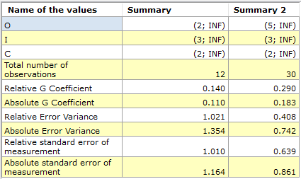
Optimization summary table
To remove all the new columns from the table, press the Clean button in the Optimization levels window.

8.7 Charts
There are three types of chart:
- Chart optimization (represented by bars) shows the data of the data summary table. The configuration options include a Charts tab in which you can select which parameters are to be represented in the bar chart and the colour chosen to display each of the selected attributes. For all the options associated with chart display, see section 9.1.2.
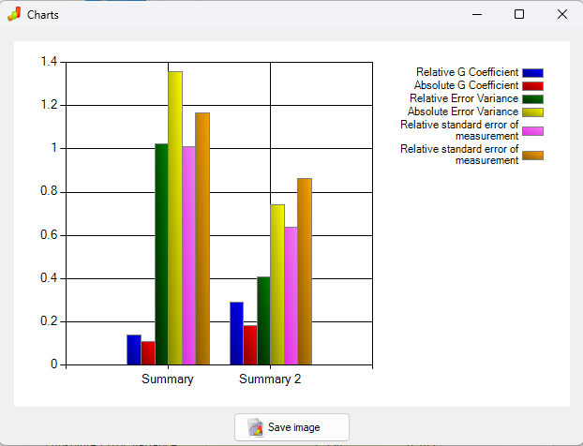
Chart optimization window
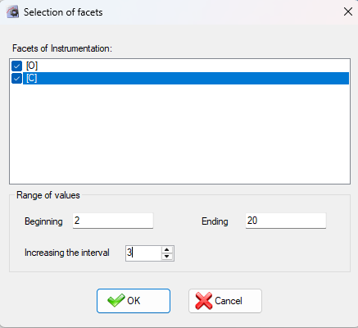
- Chart Coef G Rel and Coef G Abs (represents the values of the G coefficient for the selected facets of instrumentation). Once the type of Coefficient to be represented has been selected, the facet selection window is shown, in which you must indicate the facets of instrumentation you want to represent, the representation interval and the interval increment.
Facet selection window

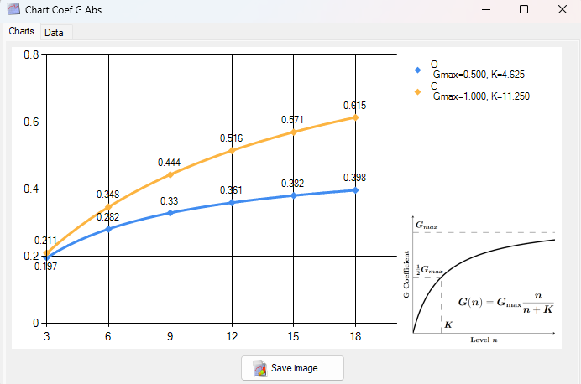
Absolute G coefficient
The legend shows the variables with which to reproduce the function followed by the curve of that facet, according to the indications in the legend (G=Gmax*n/(n+K), where Gmax is the maximum theoretical value that could be reached with an infinite level, and K is the degree of slowness with which it approaches that value).
The window has a Data tab showing in more detail the values obtained at each of the points represented. The values are classified by the process facet (the one whose level varies at each iteration), which can be selected from the drop-down tab below. If a process facet is fixed, its universe increases while keeping its type. If the facet is finite random, from the moment it reaches the size of its universe it behaves in the same way as a fixed facet.
All charts generated by SAGT can be exported as images in .jpg, .png or .gif format.

8.8 Export squares
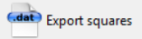
SAGT can dump the values of the sum of squares into a text file. The values are stored one per line if they are exported as a .dat file (the default format). Null values are stored as zeros, so that the resulting file is compatible with other calculation programs such as SPSS, SAS, Matlab or Scilab.
A sum-of-squares file can also be written in the EduG 6.0 export format, which makes it possible for the sums to be imported by that application. For it to be compatible with that application the facets must be identified by a capital letter (EduG names facets with letters, one per facet). The file must have the .edug extension. The file has the format of a comma-separated file in which the separator character is ‘;’. It contains the following data separated by that character: the first column holds the facet design, the second the sum of squares and the third and last the degree of freedom.

9 Tools
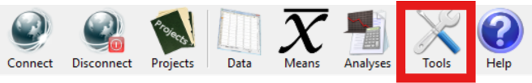
Contains various utilities for customising different parts of the program. Among them:
- Language: This option selects the language of the application. The languages available are: English, Spanish, French and Portuguese.
- Calculator: Selecting it opens the Windows calculator, if it is installed.
- Settings

9.1 Settings
Gives access to the various Settings options, where you can set options for performing the calculations, presenting reports or charts, configuring access to the Web service, and so on.

9.1.1 Reports tab
- Decimal Separator: Can be the decimal period (‘.’) or comma (‘,‘). The type of separator shown in the tables is the same one used in the reports.
- Numbers of decimals: Number of decimals with which the application's data is shown. If a figure has fewer decimals than indicated, it is padded with zeros. The calculations are always performed using the maximum possible number of decimals, regardless of how many decimals are displayed.
- Table Font: Type and size of the font shown in the tables of the reports.
- Text Font: Type and size of the font shown in the comments of the reports.
NOTE: The type and size of the application's fonts are fixed and are not altered by this option.
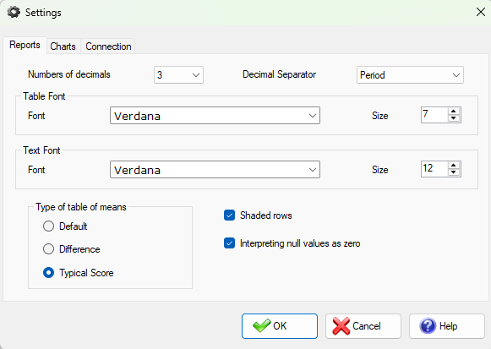
Settings window: reports tab
- Shaded rows: If the box is ticked, the tables in the reports appear with alternately shaded rows to make them easier to read.
- Interpreting null values as zero: This option directly affects all the calculations. If it is ticked, null values are interpreted as zero.
  - WARNING: although replacing null observations with zero is not usually accurate, remember that the program's calculations are not designed for unbalanced designs. See section 6.11.1 if you want to work with unbalanced designs.
- Type of table of means: There are three types of tables of means. The box ticked affects the calculations of future tables of means but not those already produced.

9.1.2 Charts tab
Allows the attributes shown in the graphical representation of the Generalizability study to be selected (G Coefficients, Variances, etc.). It is also possible to select the colour in which the bar charts are shown (summary chart of G-Parameters), as well as the values that are represented. To do so, tick the box for that value. All are selected by default.
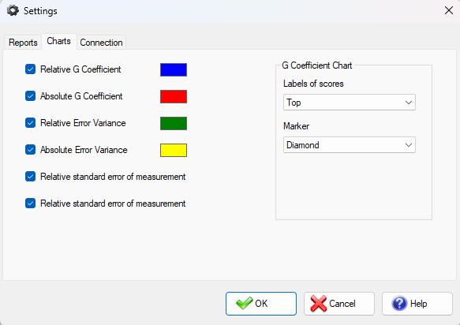
Settings window: charts tab
There is a group of parameters called G Coefficient Chart which, as its name indicates, acts on the representation of the relative and absolute G coefficients. Their colours are set by default and cannot be modified. The following configuration parameters are available:
- Labels of scores: indicates the position in which the point value label is shown. Arriba is used by default. If you select None, the value of none of the points is shown.
- Marker: Indicates the type of object used to represent the point. Diamante is used by default. None means the points are not represented.

9.1.3 Connection tab
The Workspace refers to the initial working directory from which files are opened and saved. By default this directory is “\My Documents\SAGT\Workspace”.
Apart from that, this tab allows the user's passwords to be removed and all configuration values to be restored to their defaults (all except the current application language, which is kept).
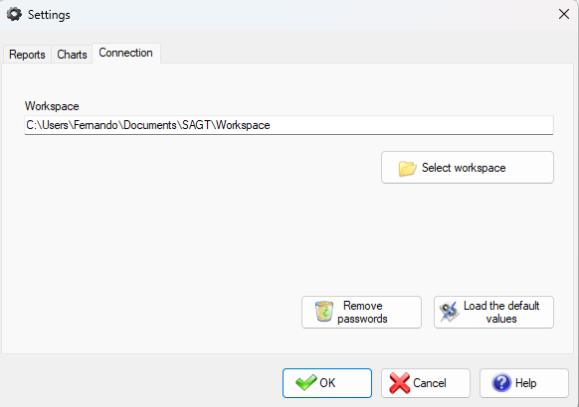
Settings window: connection tab

10 Help
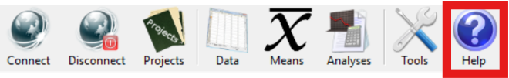
The main purpose of this option is to provide access to the application's manual in .pdf format.
- Manual: Gives quick access to this manual, in the chosen language.
- About SAGT: Shows a window with information about the version and production of the application.

11 Credits

SAGT – Software for the Application of Generalizability Theory

Authors:
Francisco Jesús Ramos Pérez
Fernando Jesús Ruano Linares

Project directors:
Prof. Dr. Antonio Hernández Mendo
(University of Málaga)
and
Prof. Dr. José Luis Pastrana Brincones
(University of Málaga)

Contributors to this project:

Prof. Dr. Ángel Blanco Villaseñor
(Methodological Adviser, University of Barcelona)

Sergio Luis González Ruiz
(Manager of the MenPas platform, )

José Antonio López López
(Program and platform for coding in observational methodology, HOISAN, )

Prof. Dr. Julen Castellano Paulis
(University of the Basque Country)

